Deepfake Image Detection

Vinayak Modi  
Student

Department of Computer Science & EngineeringUniversity Institute of Technology Barkatullah UniversityBhopal, India  
Ankit Patil

Student

Department of Computer Science & EngineeringUniversity Institute of Technology Barkatullah UniversityBhopal, India

Aryan Singh

Student

Department of Computer Science & EngineeringUniversity Institute of Technology Barkatullah UniversityBhopal, India

Mrs. Kavita Chourasia

Assistant Professor

Department Computer Science & EngineeringUniversity Institute of Technology

Barkatullah UniversityBhopal, IndiaDr. Kamini Maheswari  
Assistant Professor

Department Computer Science & EngineeringUniversity Institute of Technology

Barkatullah UniversityBhopal, India

Dr. Divakar Singh  
Head of Department

Department Computer Science & EngineeringUniversity Institute of Technology

Barkatullah UniversityBhopal, India

*Abstract* — Deepfakes, occasionally appertained to as face barters, are a type of created media in which realistic and constantly inappreciable picture and video tape variations are produced using artificial intelligence (AI). Because these modified media may be used to propagate false information, produce malignant propaganda, or indeed impersonate people for illegal ends, they pose serious pitfalls to people's reports and to society at large. Experimenters have put a lot of work into creating deepfake discovery styles that are successful in response to these mounting issues.

*Keywords— Deepfakes, deep learning, machine learning, detection, classification, artificial intelligence*

# Introduction

Artificial intelligence (AI) is used in deepfakes to produce synthetic material that mimics real world image, audio, visual, or video tape content. These edited media are constantly used to give the print that someone is talking or acting in a way that they no way would. Deepfakes may be used for good, like in jest, but they can also be used bad, like propagating false information, swaying public opinion, and ruining people's reports.

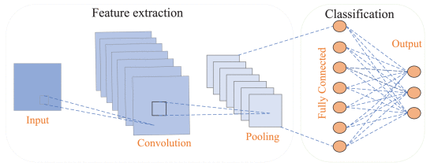The necessity for effective deepfake discovery ways is rising due to the possible detriment that deepfakes might do[1]. These ways might be used to descry deepfakes before they come extensively circulated or to warn people to possible deepfakes.

Deepfakes are a form of synthetic media that use artificial intelligence to produce realistic images of people performing conduct they no way actually did. They can be used for vicious purposes, similar as spreading false information or harming reports.

Fake content might constitute only a small part of

an otherwise long real video, as was initially suggested in[6]. Such short modified segments have the power to alter the meaning and sentiment of the original content completely.

# Models Of Deepfake

Deepfake detection is a difficult task due to the complexity of deepfake technology. However, machine learning and deep learning models have been developed to detect deepfakes with increasing accuracy. Here are some of the most common models used in deepfake detection:

* **Convolutional Neural Networks (CNNs)**: CNNs are a type of neural network that is particularly well-suited for image and video analysis. They can extract features from images and videos that can be used to identify deepfakes. For example, CNNs can detect subtle inconsistencies in facial features, skin texture, and head pose that are often present in deepfakes.[1] CNNs consist of multiple layers, including convolutional layers, pooling layers, and fully connected layers. Convolutional layers apply filters to the input image or video to extract features like edges, corners, and textures. Pooling layers reduce the output of convolutional layers, diminishing the complexity of feature maps. Finally, fully connected layers utilize extracted features to classify the input image.

**Fig:** The Basic architecture Of CNN

* **Recurrent Neural Networks (RNNs)**: RNNs are a type of neural network that can process sequential data, such as video frames or audio signals. This makes RNNs well-suited for detecting deepfakes in videos. For example, RNNs can detect temporal inconsistencies in facial movements or audio signals that are often present in deepfakes[1]. RNNs consist of multiple layers, including input layers, hidden layers, and output layers. The input layer receives the sequential data, such as video frames or audio signals. The hidden layer processes the input data and passes it to the output layer. The output layer produces the final output of the network. With the continuous evolution of deepfake technology, researchers are constantly striving to enhance the accuracy of deepfake detection models and develop novel techniques for deepfake detection.

**Fig.:** The basic architecture of a RNN

* **Generative Adversarial Networks (GANs)**: GANs are a type of neural network that can generate realistic images and videos. However, GANs can also be used to detect deepfakes. By training a GAN to generate deepfakes, researchers can then use the GAN to identify real videos that contain deepfake artifacts. This framework consists of two neural networks: a generator and a discriminator, engaged in a competitive learning process[1]. The generator attempts to fool the discriminator by producing realistic fake data, while the discriminator continuously refines its ability to distinguish between real and fake data.

Fig.: The basic architecture of a GAN.

* **Hybrid Models**: Many deepfake detection models combine different types of neural networks, such as CNNs and RNNs[1]. This can help to improve the accuracy of the model by taking advantage of the strengths of different types of networks.

In addition here are some specific deepfake detection models that have been developed:

* **MesoInception4**: This model is based on the Inceptionv4 architecture and can achieve high accuracy on both image and video deepfake detection tasks.
* **FaceForensics++**: This model is based on the EfficientNet architecture and can achieve state-of-the-art accuracy on image deepfake detection tasks.
* 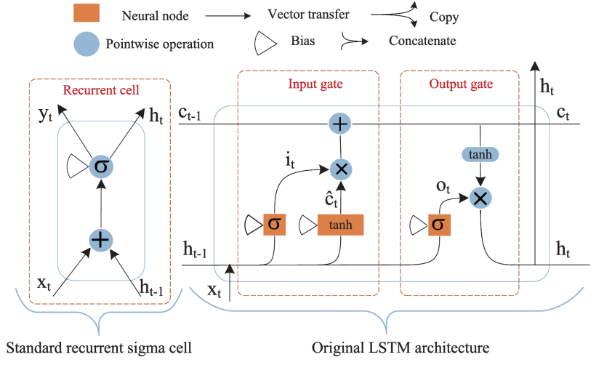**DFDC**: This model is based on the Cross-Vision Transformer (CvT) architecture and can achieve state-of-the-art accuracy on video deepfake detection tasks.As deepfake technology continues to evolve, researchers are constantly working to improve the accuracy of deepfake detection models and to develop new techniques for detecting deepfakes

# Technology Used

There are many Library used in deepfake image detection are:

1. **Tensor Flow**

It plays a crucial role in the creation and detection of deepfakes.

* **Training detection models:** TensorFlow can also be used to train deep learning models for detecting deepfakes. These models analyze features in images and videos to identify subtle inconsistencies or artifacts that might indicate manipulation.
* **Model development:** TensorFlow provides tools for building and customizing deepfake detection models based on specific needs and datasets.
* 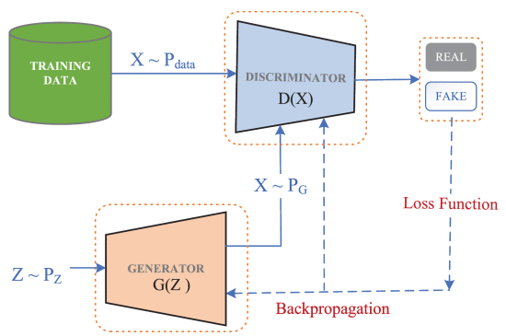**Performance comparison:** TensorFlow allows for comparing and evaluating the performance of different deepfake detection models to choose the most effective one for a specific task.

1. **Keras**

Keras, the powerful open-source library for deep learning, plays a significant role in the realm of deepfakes. While TensorFlow serves as the underlying engine for computation, Keras provides a higher-level interface that simplifies the development process.[9]

* **Building detection models:** Keras can be used to build deep learning models specifically designed to detect deepfakes. These models analyze features in images and videos to identify inconsistencies and artifacts associated with manipulation.
* **Transfer learning:** Keras facilitates the efficient use of pre-trained models for deepfake detection. Developers can leverage these models as a starting point and fine-tune them on their specific datasets.
* **Rapid prototyping of detection algorithms:** Keras allows for the rapid prototyping and testing of different deepfake detection algorithms, enabling developers to quickly evaluate and compare their performance.

1. **PyTorch**

PyTorch, another prominent open-source library for deep learning, also holds considerable significance in the realm of deepfakes. It offers a flexible and versatile framework for building and deploying deep learning models, making it a valuable tool for both creating and detecting deepfakes.

* **Research and experimentation:** PyTorch's flexible framework facilitates research and experimentation in deepfake detection. Developers can explore different architectures, loss functions, and optimization techniques to improve the accuracy and robustness of their models.
* **Open-source projects:** Several open-source projects focused on deepfake detection leverage PyTorch, providing pre-trained models and code implementations for researchers and developers.

1. **Delib**

While "delib deepfake" isn't a widely recognized term, it's likely a misspelling of "deliberate deepfake" or referring to a specific project.

To understanding dlib's role in deepfakes requires exploring its general functionalities[7].

Dlib is a powerful C++ library offering various functionalities useful for deepfakes, including:

* **Facial Landmark Detection:**

Dlib's most prominent feature is its state-of-the-art facial landmark detection algorithm. This algorithm can accurately identify 68 key points on a face, including eyes, nose, mouth, and eyebrows. This information is crucial for deepfakes as it allows for precise manipulation of facial expressions, head pose, and other features.

* **Face Alignment:**

Dlib can align faces in images and videos to a common reference frame, enabling easier comparison and manipulation. This is particularly useful for tasks like face swapping and expression transfer.

* **Head Pose Estimation:**

Dlib can estimate the pose of a head in an image or video, including pitch, yaw, and roll. This information can be used to adjust the perspective of a deepfake video to make it more realistic.

* **Image Processing Tools:**

Dlib provides various image processing tools like face detection, landmark localization, and pose estimation. These tools can be used as building blocks for developing more complex deepfake algorithms.

1. **OpenCV**

The open-source computer vision library, plays a crucial role in various aspects of deepfake creation and detection[8].

* **Facial analysis:** OpenCV algorithms can analyze facial features and detect subtle inconsistencies that might indicate manipulation. This information can be used to flag potential deepfakes.
* **Temporal analysis:** OpenCV allows for analyzing videos frame-by-frame, looking for inconsistencies in facial movements or blinking patterns that might point to manipulation.
* **Image forensics:** OpenCV offers tools for analyzing image properties and identifying artifacts that could be indicative of deepfakes.
* **Real-time detection:** OpenCV's optimized algorithms can be used for real-time detection of deepfakes in video streams, enabling immediate identification and prevention of potential harm.
* **Training data preparation:** OpenCV facilitates the preparation of training data for deepfake detection models by preprocessing images and videos, extracting features, and annotating them with labels.

1. **OS (Operation System)**

OS play a crucial role in the deepfake creation and detection process, providing the underlying platform for running the necessary software and hardware.

* **Real-time processing:** Certain OSes, especially mobile ones, prioritize real-time processing capabilities for running deepfake detection models on-device. This allows for immediate verification of content and minimizes the risk of misinformation or malicious use.
* **Security and privacy:** OSes play a crucial role in ensuring the security and privacy of user data involved in deepfake detection. Robust security features and data encryption mechanisms help protect against unauthorized access and misuse of sensitive information.
* 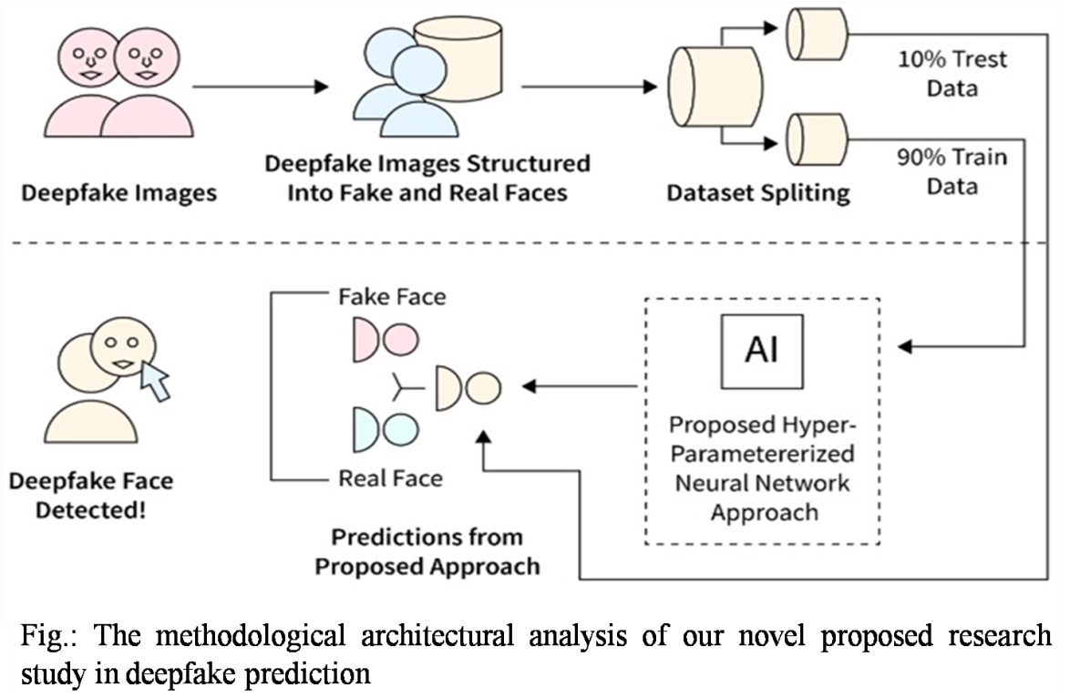**Integration with other tools:** OSes provide a platform for integrating deepfake detection models with other tools and applications, such as web browsers or video conferencing platforms. This facilitates seamless detection and flagging of potential deepfakes across various online environments.

# Study methodology

The use of deepfake images, which combine real and fake human faces, for training neural networks. These images, along with their corresponding labels (real or fake), are organized into a dataset. This dataset is then divided into three portions: training, validation, and testing. The vast majority (90%) of the dataset is used

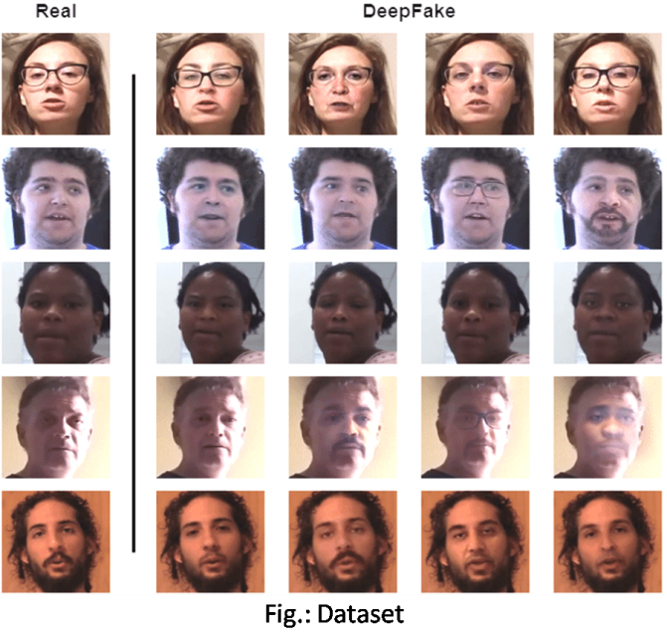for training the neural network algorithms[3]. A novel approach called DFP is then employed and its parameters are optimized to achieve the highest possible accuracy in deepfake detection. Finally, the performance of the trained neural network is evaluated on the remaining 10% of the dataset, representing unseen data. A new deep learning-based approach has been proposed that can predict the outcomes of unseen data with high accuracy[3].

This advanced approach is in a generalized form and is capable of detecting fake and real faces in deployment.

# Datasets

Forensics datasets can be classified into two broad types: traditional and DeepFake datasets.

Traditional forensics datasets are created manually with extensive manual effort under carefully controlled conditions such as camera artifacts, splicing, inpainting, resampling and rotation detection.

Deepfake are generally created by GAN-based models, which are very popular due to their realistic performance.

Deepfake dataset that aims to perform forensic tasks for facial identification and segmentation to forged images.

The 90% train portion of the dataset is utilized for training employed neural network techniques[3].

The generated deepfake images combine numerous faces, separated by nose, eyes, mouth, and whole face. The dataset contains 9000 images of real and 1000 images of fake faces.

# Deepfake Detection

Deepfake detection is a crucial area of research that aims to improve the confidentiality and integrity of multimedia content. Detecting deepfakes involves analyzing the multimedia content to determine whether it has been tampered with or is original.

Traditionally, forgery detection techniques were used to detect deepfakes. However, in recent years, AI-based deepfake detection techniques have become more popular. Researchers have developed several deep learning models, such as Convolutional Neural Networks (CNNs), Recurrent Neural Networks (RNNs), and Generative Adversarial Networks (GANs), to detect deepfakes with increasing accuracy.

## Traditinal Frorensics based techniques:

## To modify image content, various traditional image processing technologies are employed, such as copy-move (splicing), resampling (resize, rotate, stretch), and the addition and/or removal of any part of the image[1]. Traditional forensics-based techniques are commonly divided into two types: active and passive.

## Traditional forensic-based techniques played a crucial role in detecting deepfakes. These techniques relied on the analysis of specific artifacts and inconsistencies introduced during the manipulation process. While still valuable in some cases, they can often be bypassed by advanced deepfake creation methods.

## Here are some of the most common traditional forensic-based techniques for deepfake detection:

* **Metadata Analysis:** Examining the metadata of an image or video can reveal inconsistencies that point to manipulation. For example, mismatched timestamps or camera model information can be red flags.
* **Image Quality Analysis:** Deepfakes often exhibit subtle quality reductions due to compression artifacts or inconsistencies in color balance and noise patterns.
* **Image Cloning Detection:** Identifying cloned regions in an image can be achieved by analyzing patterns in noise or pixilation.
* **Steganalysis:** This involves detecting hidden messages or data embedded within the image, which could indicate manipulation.

## Deepfakes Forensics-Based Techniques:

While deep learning models have become the dominant force in deepfake detection, **forensic-based techniques** still play a valuable role in the fight against manipulated media[1]. These techniques analyze specific artifacts and inconsistencies introduced during the deepfake creation process, offering valuable insights and complementary information to AI models.

Some key forensics-based techniques used for deepfake image detection:

* **Compression Artifacts:** Deepfakes often exhibit artifacts due to compression during manipulation. Analyzing JPEG compression artifacts can reveal inconsistencies compared to original images.
* **Color Balance and Noise Patterns:** Subtle differences in color balance and noise patterns between manipulated and original regions can be indicative of deepfakes.
* **Pixilation and Blurryness:** Regions where manipulation occurred might exhibit pixilation or blurring due to resizing or blending.
* **Inconsistencies in Timestamps:** Comparing timestamps within the image's metadata with timestamps from external sources can reveal manipulations if they don't match.
* **Noise Pattern Analysis:** Different noise patterns between cloned and original regions can be detected using statistical methods.
* **Pixel-Level Analysis:** Analyzing individual pixels for inconsistencies in color, brightness, and noise can reveal cloning attempts.

# Challenges For Deepfake Detection

GANs, which are popular articial intelligence (AI) techniques, consist of two discriminative and generative models that compete against each other to improve their performance to generate believable fakes[1].

Some of the difficulties faced by DeepFake detection techniques include a lack of datasets, unknown types of attacks on media, temporal aggregation and unlabeled data.

1. Deepfake technology is constantly evolving, making it difficult for detection models to keep up. These techniques can include advanced GANs, morphing techniques, and AI-assisted manipulation methods that are challenging to detect.
2. Training deepfake detection models requires large datasets of both real and deepfake images. However, collecting representative datasets can be difficult and expensive, especially for new and emerging deepfake techniques.
3. Malicious actors can deliberately create deepfakes designed to fool specific detection models[4]. These adversarial attacks exploit vulnerabilities in the models and can significantly reduce their detection accuracy.
4. Deepfake detection models often perform well on the specific datasets they are trained on. However, their performance can decline significantly when applied to different datasets or real-world scenarios. This lack of generalizability limits the practical applicability of deepfake detection models.
5. Deep learning models often function as black boxes, making it difficult to understand how they make decisions. This lack of interpretability hampers the ability to debug and improve detection models and can raise concerns about potential biases in their decisions.
6. Training and deploying deepfake detection models can be computationally expensive, especially for resource-constrained environments. This can limit the widespread adoption of deepfake detection technology.
7. Balancing the need for effective detection with user privacy remains a significant challenge as deepfake detection methods often rely on sensitive personal data, such as facial images and videos.
8. The use of deepfake detection technology raises various legal and ethical concerns, such as potential misuse for surveillance, discrimination, and manipulation. It is crucial to establish clear guidelines and regulations for the responsible development and use of this technology.
9. While some deepfake detection models can achieve near real-time performance, many still require significant processing time.[5] This limits their practical application in scenarios where real-time detection is critical, such as social media platforms and live video streaming.
10. Deepfake detection models can be biased based on the data they are trained on. This can lead to unfair and discriminatory outcomes, particularly for marginalized groups. Mitigating bias and ensuring fairness in deepfake detection models is an ongoing challenge.

# Result

Our method is compared to the most recent techniques for temporal action localization and deepfake detection using the entire proposed dataset. In our dataset there is a single label for the fake segments, so it is reasonable that the GAN score is relatively high[6]. We also evaluated the performance of our visual-only unimodal method, which shows average results. We also evaluated the same methods on the subset of the proposed dataset. he performance of the visual-only methods is improved, and for our method, the visual-only score improves by 8.55%.

Deepfake Classification: Our method was not explicitly trained for classification forge faces and objects. This explains its slightly lower performance on DFDC dataset.

The proposed method can sometimes provide inaccurate results for images with very small manipulated in pixel (equal to or less than 0.5 pixel value). This is because when the visual transition between the real and manipulated sections is smooth, the method may struggle to accurately identify the manipulated segment, leading to unreliable output.

# Conclusion

DeepFake, a new and prominent technology. It covers the basics, benefits, and risks associated with DeepFake, including GAN-based DeepFake applications. In this we also discuss DeepFake detection models. Most existing deep learning-based detection methods are unable to transfer and generalize, indicating that multimedia forensics has not yet reached its peak. Many important organizations and experts are working to improve applied techniques. However, more effort is needed to ensure data integrity, which requires additional protection methods. Additionally, experts predict a new wave of DeepFake propaganda in AI against AI encounters where neither side has an advantage over the other.

# References

1. Asad Malik, Minoru Kuribayashi, Sani M. Abdullahi And Ahmad Neyaz Khan (2022) DeepFake Detection for Human Face Images and Videos: A Survey.
2. Hasin Shahed Shad , Md. Mashfiq Rizvee, Nishat Tasnim Roza, S. M. Ahsanul Hoq, Mohammad Monirujjaman Khan, Arjun Singh, Atef Zaguia and Sami Bourouis (2023) Comparative Analysis of Deepfake Image Detection Method Using Convolutional Neural Network, Computational Intelligence and Neuroscience
3. Raza, A.; Munir, K., Almutairi, M. (2022) A Novel Deep Learning Approach for Deepfake Image Detection.Image Detection. Appl. Sci. 2022
4. Li, Y., & Lyu, S. (2020). Exposing deepfake videos by leveraging visual artifacts. In Proceedings of the IEEE/CVF Conference on Computer Vision and Pattern Recognition
5. Zhixi Cai, Kalin Stefanov, Abhinav Dhall and Munawar Hayat, Do You Really Mean That? Content Driven Audio-Visual Deepfake Dataset and Multimodal Method for Temporal Forgery Localization.
6. K. Chugh, P. Gupta, A. Dhall, and R. Subramanian, “Not made for each other- Audio-Visual Dissonance-based Deepfake Detection and Localization,” in ACM MM, 2020, pp. 439–447.
7. V. Kazemi and J. Sullivan, "One millisecond face alignment with an ensemble of regression trees," 2014 IEEE Conference on Computer Vision and Pattern Recognition, Columbus, OH, USA, 2014, pp. 1867-1874, doi: 10.1109/CVPR.2014.241.
8. P. F. Felzenszwalb, R. B. Girshick, D. McAllester and D. Ramanan, "Object Detection with Discriminatively Trained Part-Based Models," in IEEE Transactions on Pattern Analysis and Machine Intelligence, vol. 32, no. 9, pp. 1627-1645, Sept. 2010, doi: 10.1109/TPAMI.2009.167.
9. Kaiming He Xiangyu Zhang Shaoqing Ren Jian Sun,Deep Residual Learning for Image Recognition https://arxiv.org/abs/1512.03385.